Camille GOLLIOT & Tifaine DECLERCQ SAE 2.04

***UCAS June 2023 undergraduate application deadline reports***

1. In a bar or line graph, show the evolution in the numbers of :

* All applicants between 2006 and 2023

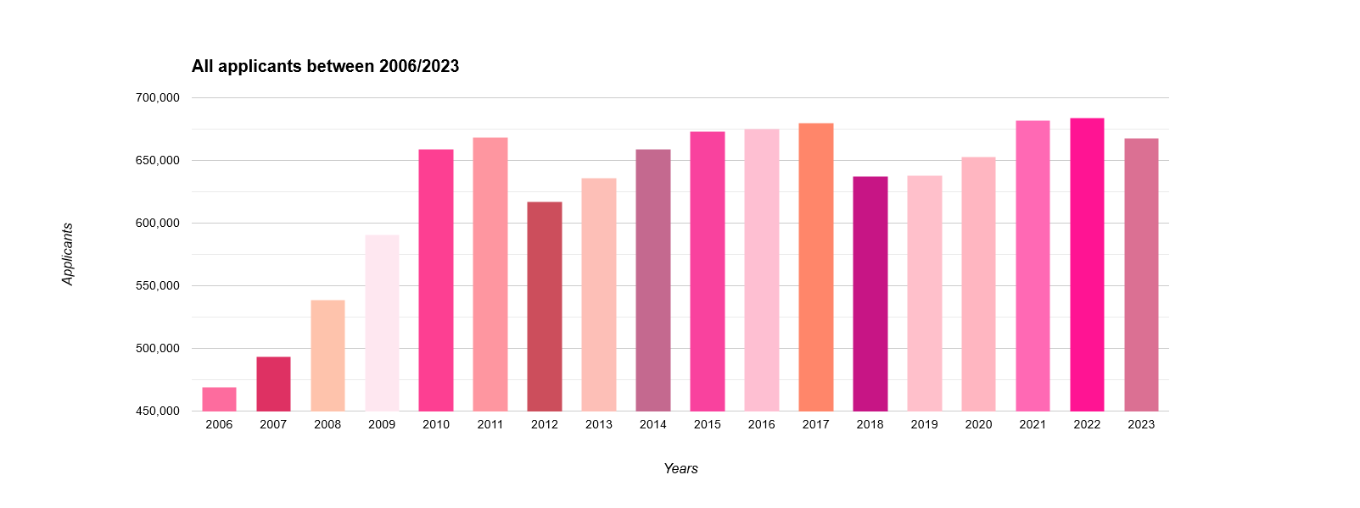

* International applicants from the EU (excluding UK) between 2006 and 2023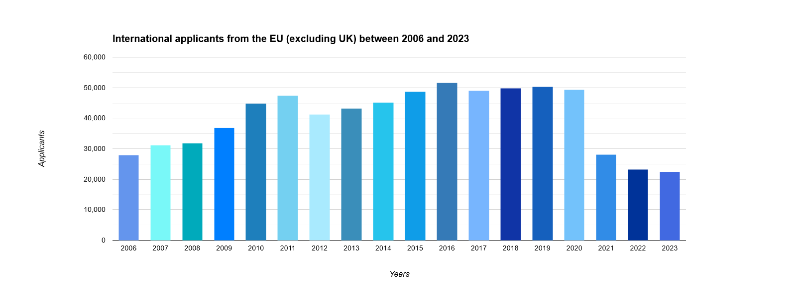
* International non-EU applicants between 2006 and 2023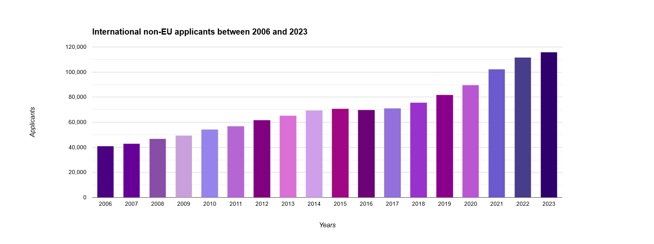

1. Compare the figures for applications between 2021 and 2023 of applicants from :

* England

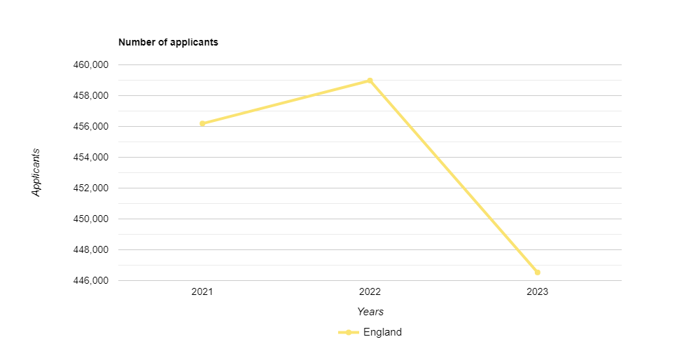

* EU (Excluding UK)

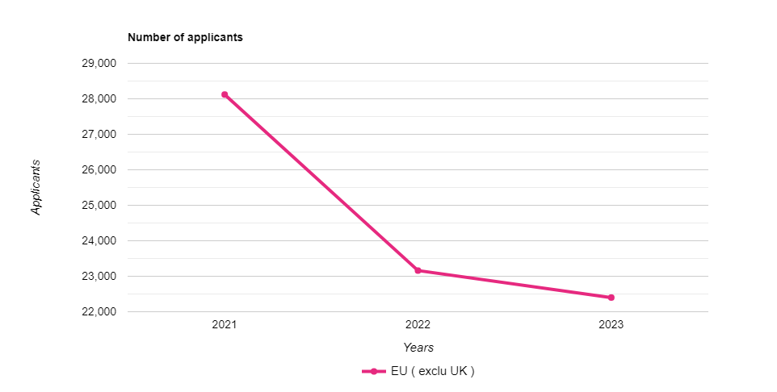

* Northern Ireland

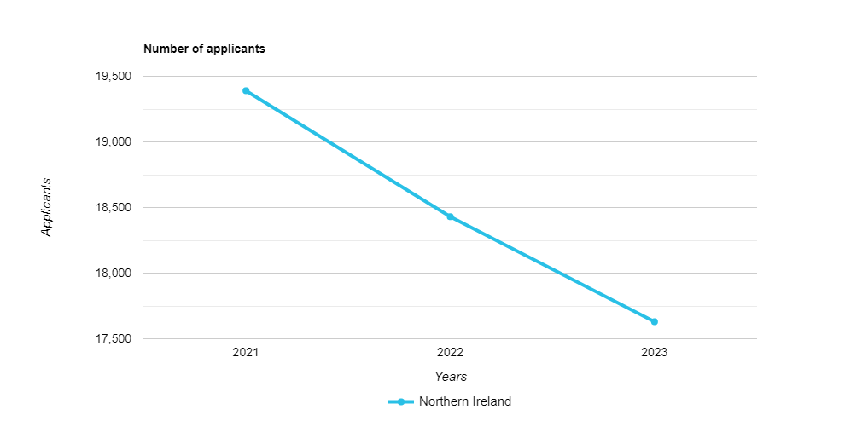

* International not EU

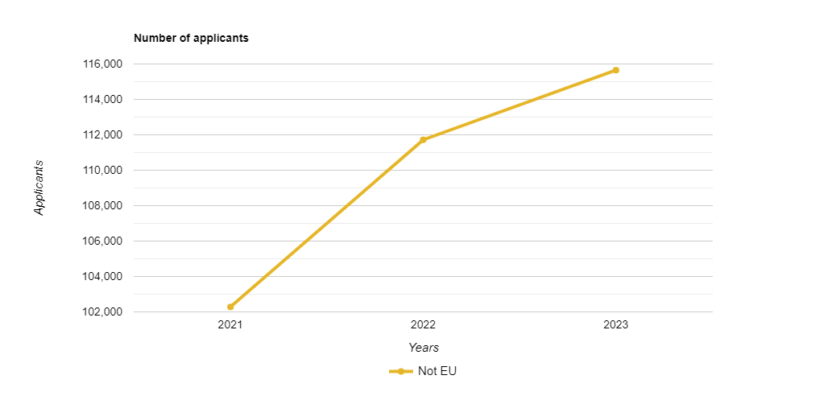

* Scotland

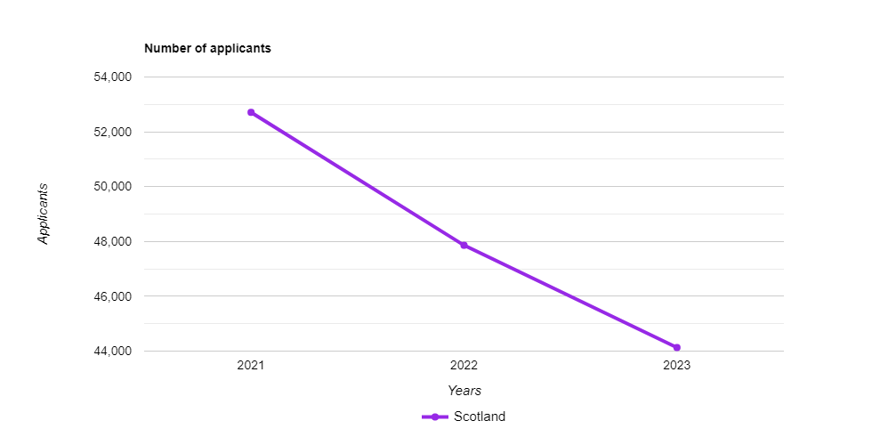

* Wales

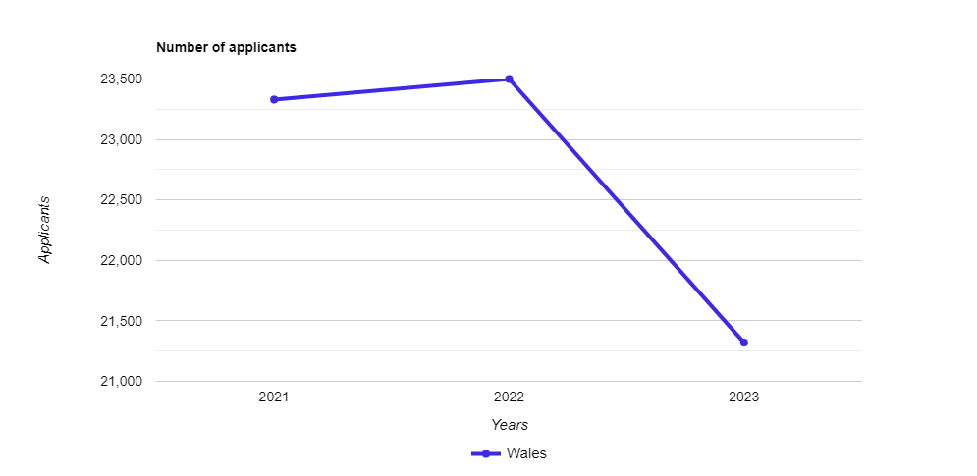

| **Observation :**  For countries in Europe (excluding the UK), we can observe a constant decline, the same goes for Northern Ireland and Scotland. Going from 28,120 to 22,400 applicants for European countries (excluding the UK), going from 19,390 to 17,630 applicants for Northern Ireland and going from 52,710 to 44,130 applicants for Scotland.  For England and Wales, we can see an increase between 2021 and 2022 but a decrease between 2022 and 2023.  Going from 456,190 to 458,980 then to 446,530 applicants for England in 2023. Going from 23,330 to 23,500 then to 21,320 applicants for Wales in 2023.  And for countries outside Europe, we can observe a constant evolution going from 102,280 to 115,650 applicants in 2 years. |
| --- |

1. Has Brexit had an effect on the number of French applicants to UK universities ? What about other EU countries ? Use bar or line graphs to compare the figures before and after Brexit.

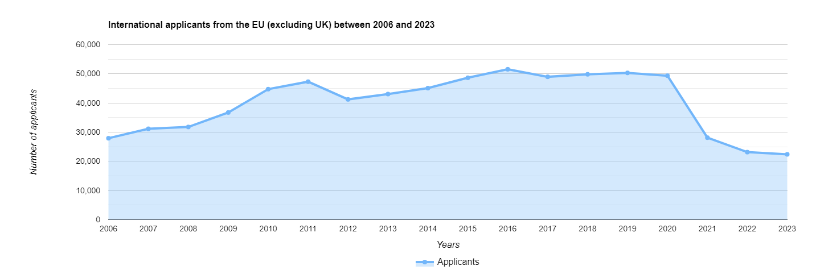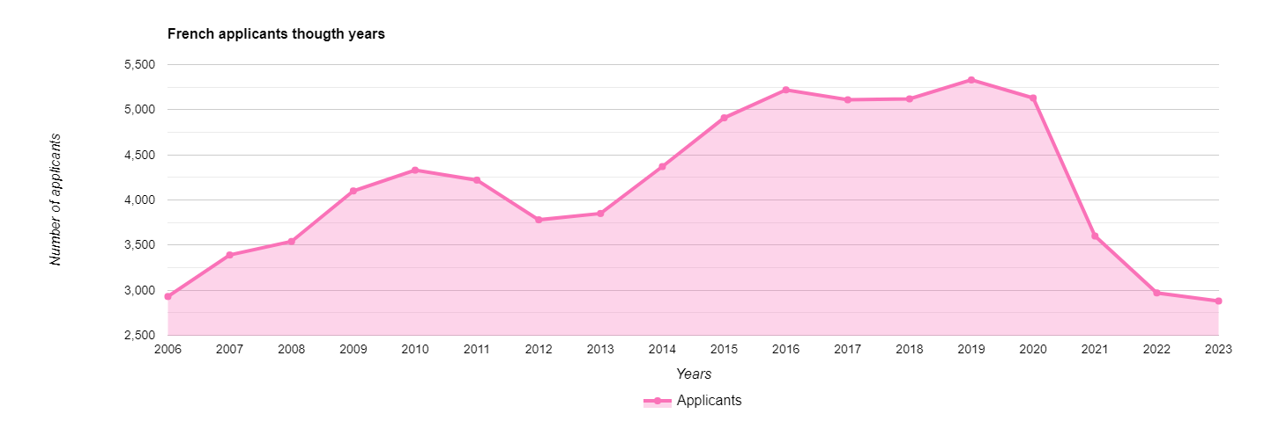

| **Observation :**  Brexit took effect on January 1, 2021, we can see on the graphs that a drop in applicants is being felt whether in the EU or even in France.  The curves were in almost constant evolution until 2020 (small drop towards the year 2012), we can see that in 2021, the number of applicants dropped drastically from around 5,130 to 3,600 applicants in 2021 then to 2,880 in 2023, for France.  For European countries, we can see a drop from around 50,000 to 28,000 applicants in 2021, then to 22,500 applicants in 2023. |
| --- |

1. Which country (excluding the UK) had the highest number of applicants in June 2023 ? Indicate the number to justify your answer.

| **Answer :**  The country with the most applicants (excluding UK) in June 2023 is China with 30,700 applicants (including men and women). If we only talk about male applicants, China had 14,810 applicants in June 2023. |
| --- |

1. Which country (excluding the UK) had the highest number of female applicants in June 2023 ? Indicate the number to justify your answer

| **Answer :**  The country with the most female applicants (excluding the UK) in June 2023, is China with 15,890 applicants. |
| --- |

1. Show how the number of applicants from Australia has evolved between 2006 and 2023 in a bar or line graph. Compare the figures for all age groups and genders.

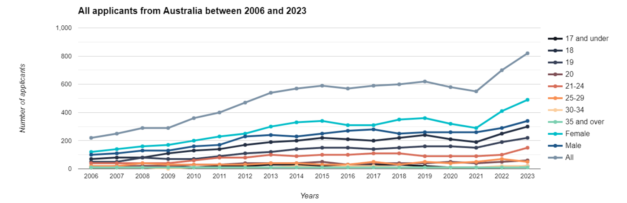

| **Observation :**  On this graph representing the number of applicants in Australia from 2006 to 2023, we can firstly observe that the curve is in almost constant evolution if we take the overall statistics, that is to say the “All” curve. A first and slight drop should be noted in 2016, going from 590 to 570 applicants. The second drop we can see is from 2019 to 2021 going from 620 to 550 applicants.  At the gender level, we can see that women have always been more numerous than men.  The average of female applicants, over the 18 years of the graph, is 108 applicants while that of male applicants is 74.  In terms of the different age groups, we can say that the 35 and over, the 30-34, the 25-29, the 20 and 17 and under year olds have very few applicants over all these years. On the other hand, 21-24 year olds, 19 year olds and 18 year olds are hugely present.  The average of applicants, during these years, is 23 applicants for the first selection while the average of applicants for the second selection is 129. |
| --- |

1. Show how the number of applicants from China has evolved between 2006 and 2023 in a bar or line graph. Compare the figures for all age groups and genders.

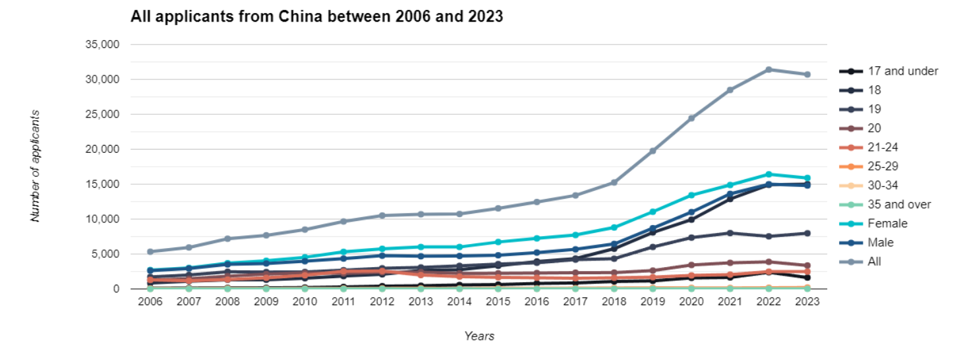

| **Observation :**  On this graph representing the number of applicants in China from 2006 to 2023, we can see that the curve is constantly evolving, there is no drop represented except for a very small one in 2023. The curve taken for the data is that from the “All” category.  From 2012, we can observe stagnation until 2014 then a very small evolution for 4 years. And finally, a huge increase from 2018 to 2022, doubling the number of applicants, from 15,240 to 31,400.  In terms of gender, it is the same as the applicants in Australia, there have always been more female applicants than male applicants.  The average female applicants over these 18 years is 3532 applicants while men have 3292 applicants on average.  In terms of age groups, we can see a slight difference with the applicants from Australia. The most represented age groups are the youngest, except those 17 and under, and the higher the age, the fewer applicants there are.  The average for 18, 19, 20 and 21-24 year olds is 7202 applicants while the average for 17 and under, 25-29, 30-34 and 35 and over is 472 applicants.  The second section is not even a tenth of the first section while in Australia the smallest section is a fifth of the second. |
| --- |